Post Lab Validation Circular Motion

Name ______________________

A group of students conducted an experiment where a rubber stopper was whirled around in a horizontal plane, as shown below.

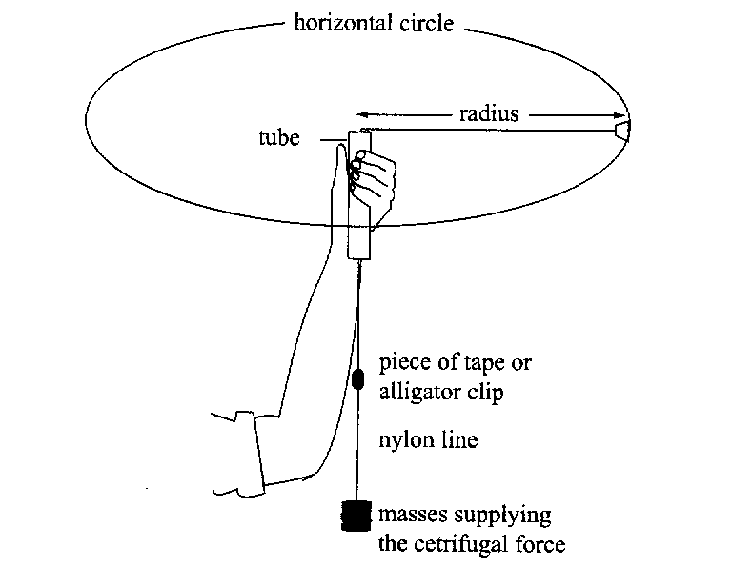

The following results were recorded.

1) Complete the line of data. (working space below table ) (4 marks)

Radius r (m) = 0.600

Mass providing centripetal force (kg) | Centripetal force (N) | Time for 20 Turns |  | Average time per turn (s) | Velocity v (ms⁻¹) | Velocity v² (m²s⁻²)
Mass providing centripetal force (kg) | Centripetal force (N) | Trial 1 (s) | Trial 2 (s) | Average time per turn (s) | Velocity v (ms⁻¹) | Velocity v² (m²s⁻²)
0.200 |  | 10.2 | 10.7

- Assuming the students used a metre ruler with mm graduations and a stopwatch which measures to 1/10th of a second,
Calculate the % uncertainty for the velocity calculation. (4 marks)

3) The students completed the experiment using a different mass but with a constant radius of 0.600 m and plotted the attached graph. Analyse their graph and data (as in your experiment) to determine the mass of the rubber stopper used. Show all necessary calculations and logic.

(4 marks)

Velocity Squared (ms-2) | Force (N)
6.5 | 0.5
20 | 1.5
33.5 | 2.5
47 | 3.5
59 | 4.5
74 | 5.5

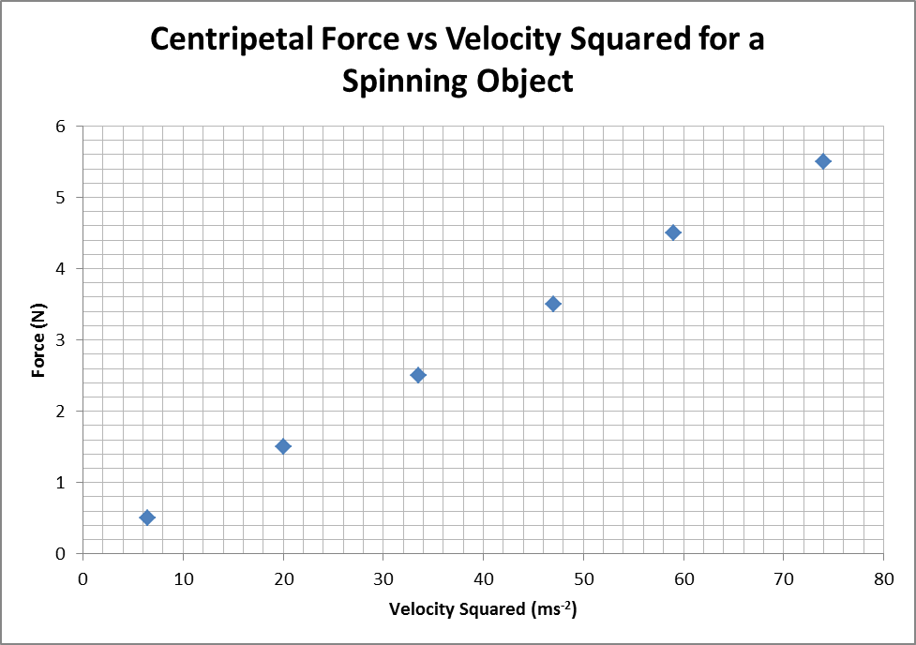
4) One of the major errors of this experiment is that the mass is not spinning horizontally. Briefly describe how this can affect the results of the experiment? (3 marks)

.

